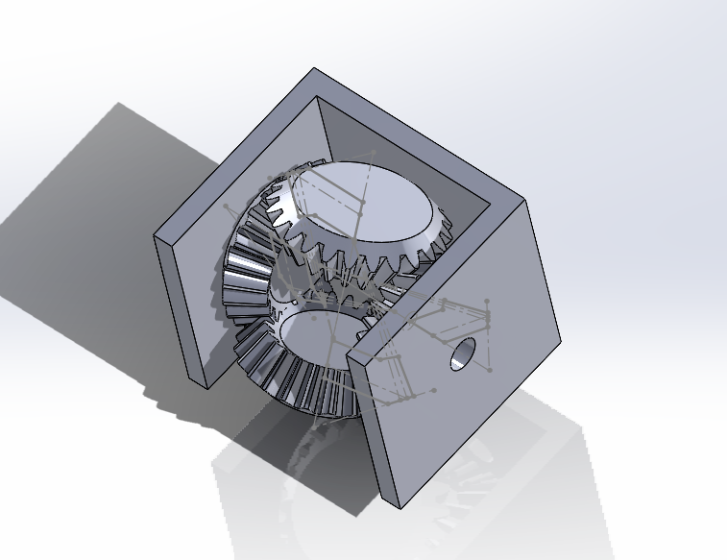

2 motors on the either side of the hole and will give motion.

Want to show tom and jerry chase 1 side as tom and other side as jerry .